Optimizing VMMC scale-up and targeting in the test and treat era

Adam Akullian

Exported on Jul 02, 2021

Table of Contents

**No table of contents entries found.**

**Goal: Evaluate the effectiveness and insurance against resurgent incidence of sustained VMMC programs over the next two decades**

**Strategic approach:**

**Questions from the PST (Maaya Sundaram and Michelle Morrison):**

1. Given the evolution of HIV epidemiology and disease response in our priority countries, is continued scale up of VMMC and maintain (sustaining) coverage necessary to maintain low incidence and / or “epidemic control”?
2. If so, under what scenarios – e.g. with current tx coverage and viral suppression?  Only if we lose ground on tx coverage and viral suppression

* Under what HIV epi and disease response scenarios does maintaining VMMC coverage remain cost effective and / or cost saving?
* For scenarios where sustaining VMMC coverage makes sense, for how long and what age groups should we focus on for the greatest immediacy of impact, magnitude of impact, and most cost effectiveness?
* Under future scenarios of continued tx coverage and viral suppression as well as introduction and scale of effective prevention (e.g. CAB LA, Islatravir, etc), does sustaining VMMC remain relevant and cost effective to maintain low incidence or epidemic control?
* If we are considering sustaining VMMC as an “insurance policy”, under what do we have to believe for the investment to be cost effective or justifiable?  E.g. how much ground must we lose in tx coverage or viral suppression or inability to scale CAB that high coverage of VMMC will help maintain lower incidence?

**Notes from John Stover in email 7/2/2021**

**Incidence**. Since future incidence is key to the cost-effectiveness of VMMC, we could prepare incidence projections with uncertainty for each of the priority countries so that we could explore the likelihood that VMMC would not be needed. One example, shown below, would be to establish bounds using constant coverage as the upper bounds and UNAIDS 2025 goals as the lower bound. These charts would simply solidify the case that VMMC will be needed almost everywhere.

**Implementation**. How to implement VMMC programs seems to be the biggest question facing the Foundation. I can think of a number of dimensions to this issue, most of which could be addressed through modeling:

* 1. **Age group**. What can we say about the immediate and long term effects of targeted different age groups? We already have a lot of work done on this question. Can we combine it with what we know and don’t know about the feasibility, difficultly and cost of reaching different age groups? Even if we don’t know much, what can we say about how much more effort we might be willing to spend to get more immediately impact? How does age group targeted relate to long-term sustainability?
  2. **Campaign/routine services**. What can we say about the benefits and disadvantages of campaign versus routine service approaches? How do the resources needs compare? Can we say anything about the sustainability of each approach?
  3. **Neonatal**. I suppose we should at least address the question as to whether neonatal circumcision should be an option for sustainability.
  4. **Integration**. What can we say about the potential to integrate VMMC services with other health services appropriate for the age groups targeted: HIV and STI screening, HPV vaccine, sex education, violence prevention, etc.
  5. **Public health system vs private sector vs NGO implementation.** Do we best ensure sustainability by encouraging Ministries of Health to take this on as a routine service, or build local NGO capacity to implement services, or engage the private sector? Can VMMC be built into health insurance schemes?
  6. **Geography.** Does it make sense to target resources to high incidence areas within a country?

**Notes:**

* 0-14 no longer allowed in VMMC programs.
* VMMC efficiency driven by incidence
* Are we costing this correctly?  Costs of VMMC by age is not known and so need to make assumptions.
* How would us as modelers inform programmer as to what the most efficient ways of implementing VMMC over next xyz time horizons?
* Insurance policy of VMMC scenarios
* How the program is implemented - campaign approach versus integration into health system.  Long term an annual campaign may make more sense - lots of VMMCs in a short period of time.  Differences in cost between these two approaches?
* Impact as outcome of interest, which could inform targeting of campaigns. And to access boys to implement other interventions and information.  Campaigns are more geared towards older men whereas younger men VMMC is more incorporated into health system

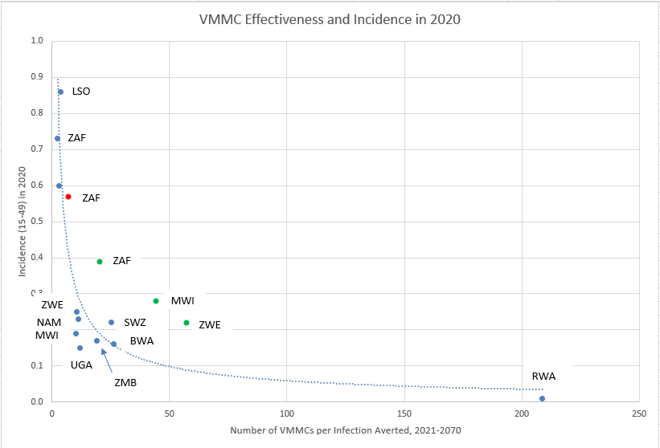

**Age-targets for VMMC Refs:**

1. Rakai Cohort study: <https://pubmed.ncbi.nlm.nih.gov/33043978/>
2. Modeled population level effect across many countries (80% coverage through 2025): <https://pubmed.ncbi.nlm.nih.gov/22140367/>
3. Age-targeting effectiveness: <https://pubmed.ncbi.nlm.nih.gov/27410966/>
4. Age-targeting in Swaziland <https://journals.plos.org/plosone/article?id=10.1371/journal.pone.0156776>

**Milestones:**

* Initial calibration complete
* Define initial set of age-targeting scenarios and campaign duration
* Define "health care accessible" population by risk-group in men for modeling differences in uptake of circumcision by risk profile of young versus older adults.

**Model scenarios and figures**

1. VMMC coverage held at 2016 levels (StatusQuo)
2. Program stops completely in 2020 (StopVMMC2020)
3. VMMC to 80% of 15-19 y/o beginning in 2020 and sustained through simulation end (VMMC80%1519)

|  |  |  |  |  |  |
| --- | --- | --- | --- | --- | --- |
| **Scenario** | **Description** | **VMMC coverage** | **Duration of campaign** | **Figure 1. MC coverage** | **Figure 2. Effectiveness (across all scenarios)** |
| StatusQuo | held at 2016 levels for all age-groups | 44% (10-14)  38% (15-19) | Through 2050 | _scroll_external/attachments/image2021-7-2_15-36-29-27b3e22671d1286214a2e048fd8648b37fee3493305a95a6d4b036cacd16ca66.png | _scroll_external/attachments/image2021-7-2_15-33-20-9d4755e0c7a8bb1808adef2276976e12d0ba863a4abe8b92ad977218e273c1fa.png |
| StopVMMC2020 (reference) | program stops in 2020 | New cohorts are uncircumcised starting in 2020 (linear ramp-down from 2016 to 2020) | NA | _scroll_external/attachments/image2021-7-2_15-35-54-30608ffd8d2623c56e05b01f9782c3a86470f855647888b33c34eca442dfc52a.png | _scroll_external/attachments/image2021-7-2_15-34-4-8570fd2aecc08297032b72964b22cefb130d6569a694adc2d7eeb1346dca5745.png |
| VMMC to 80% in 15-19 y/o | Immediate scale-up of VMMC to reach 80% in each age-group | Immediate 80% coverage across age-groups | Through 2050 | _scroll_external/attachments/image2021-7-2_15-35-25-fa86c2e95712a6d2ce5da7e8eb0a53a9fc6119dee2f74ab67b438cdb9538bcd2.png | _scroll_external/attachments/image2021-7-2_15-34-46-8d0516936582622b8ce8805281d15837f2c1e6e1a7df26eb8339ede47b49ee9c.png |

**Comparison plots:**

_scroll_external/other/unknown-attachment-a203e43a69f74e78d44e6d52e2503b73225c12556e90c7729a593c39f6800c8d

_scroll_external/other/unknown-attachment-a203e43a69f74e78d44e6d52e2503b73225c12556e90c7729a593c39f6800c8d

**Parameterization**

**Modeling considerations:**

**Run Model in cmd:**

**Activate virtual env:**

cd C:\Users\aakullian\environments\dtk-tools

Scripts\activate

**Project root:**

cd C:\Users\aakullian\Dropbox (IDM)\GitHub\EMOD\_eswatini\eSwatini2

**Run scenarios:**

python run\_scenarios.py -c optim\_script.py -m provided --samples resampled\_parameter\_sets\_n2.csv -o VMMCAGETARGETINGBYYEARTEST -s TEST1 --table scenarios\_VMMC.csv

Add transmission report and sweep across end year of VMMC campaign:

python run\_scenarios.py -c optim\_script.py -m provided --samples resampled\_parameter\_sets\_n2.csv -o VMMC\_AGETARGETING\_BY\_YEAR\_SWEEP\_TEST -s TEST1 --table scenarios\_VMMC.csv --files output\ReportHIVByAgeAndGender.csv,output\TransmissionReport.csv

python run\_scenarios.py -c optim\_script.py -m provided --samples resampled\_parameter\_sets\_n1.csv -o Eswatini\_VMMC\_Baseline\_80pct\_1519\_2020 -s Eswatini\_VMMC\_Baseline\_80pct\_1519\_2020 --table scenarios\_VMMC.csv --files output\ReportHIVByAgeAndGender.csv,output\TransmissionReport.csv